**General tips for Judging Top Rope 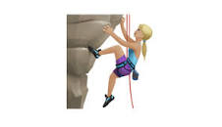6/9/2023**

🎉 Do cheer and support everyone on the walls.

Judges are NOT ALLOWED to give beta,advice or reminders to climbers before or when they are on the wall.



🕓 Climbers have 1 attempt only within the climbing time - this varies between competitions (4-6 mins).

😲 Judges are NOT ALLOWED to change how you are judging a climb after the 1st climber, consistency is important to be fair to all.

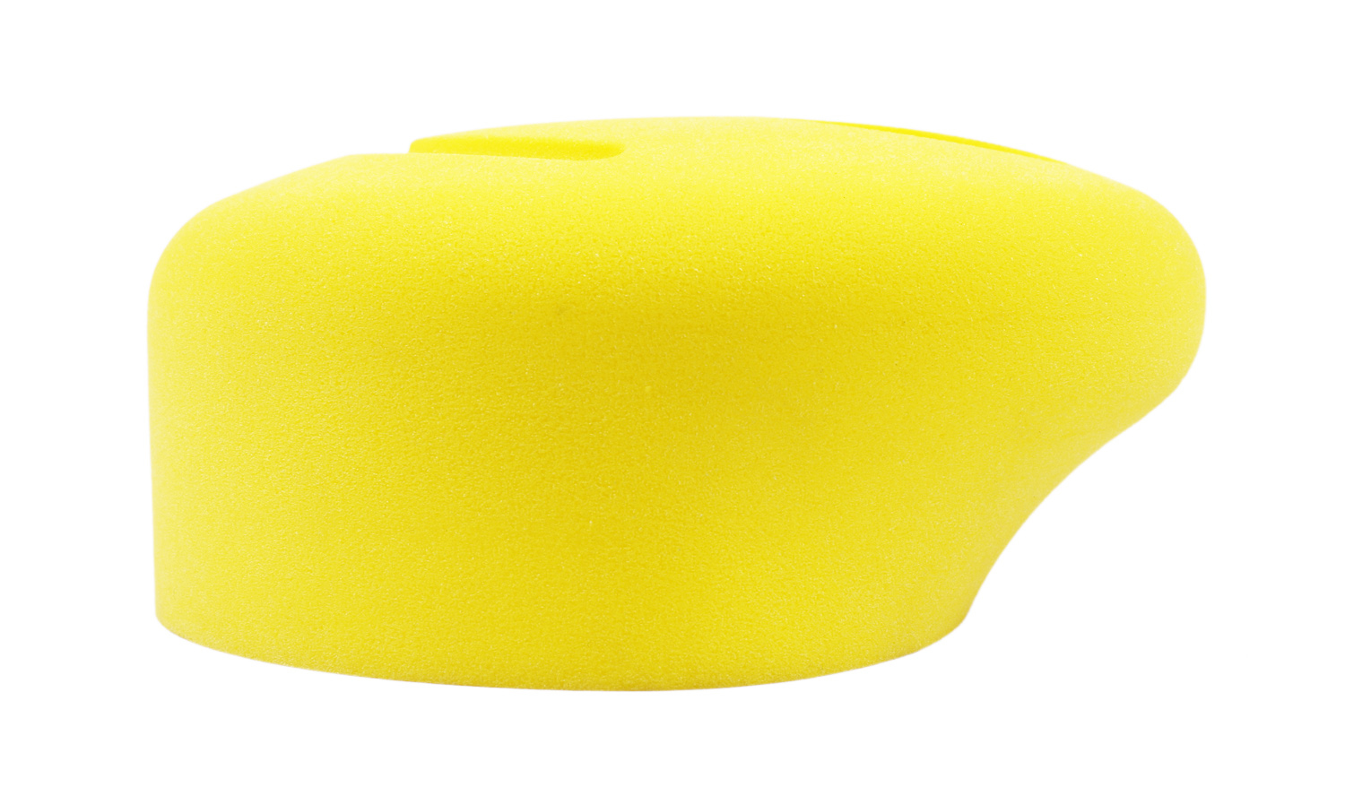Judges should always keep track of the hold the climber is on.

**Starting a climb**  

 A climb has started when both feet have left the ground.

🦶 Climbers must have 1 foot on the ground before starting.

Climbers are ALLOWED to hop as a change of position at the judges discretion, a change of foot is ok, provided 1 foot is always on the ground.

**Climbing a Top Rope climb** 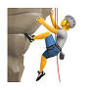

❌ Climbers are NOT ALLOWED to use any part of the climbing surface or structures/holds demarcated as out of bounds by continuous black tape.

Climbers are NOT ALLOWED to weight the rope (lean on the rope).

✅ Climbers ARE ALLOWED to touch the black tape itself.

If there is tape covering the edges of a volume or hold, climbers are NOT ALLOWED to use that edge to complete the climb.



Climbers are ALLOWED to Brush/touch an incorrect hold.

🏋 Climbers are NOT ALLOWED to use/weight an incorrect hold, they will get called down.

🤾🏼‍♂️ If the climber falls that finishes the climb, the same if 1st hold or later hold.

**Control & Use a hold** 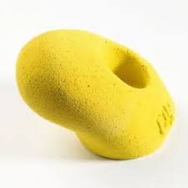

🖐️ Control is awarded if the climber USES the hold to achieve OR change a stable body position.

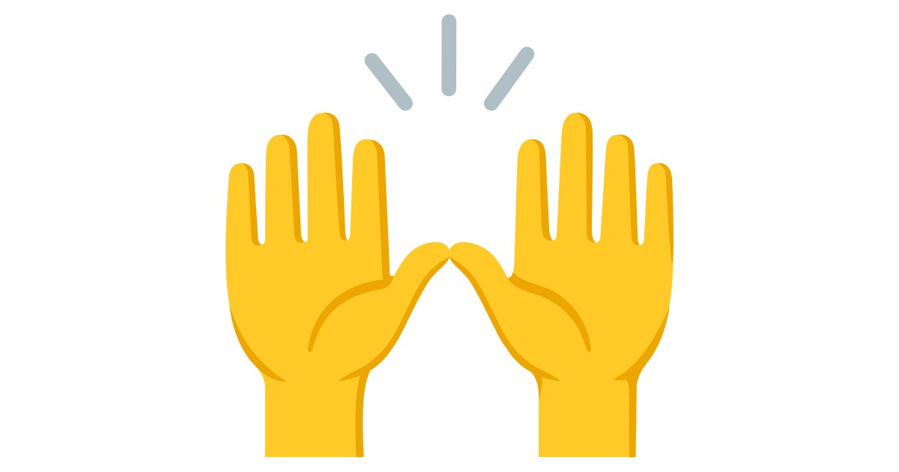 Control is only awarded when a climbers hands (not feet) are used to control the hold/volume.

➕ A plus + is awarded if the climber has made use of the hold to make both

* 1 progressive movement of the climbers centre of mass OR hips

AND

* a movement of either or both hands toward the next sequential handhold eg if climber is on hold 9, & hold 10 is left, & hold 11 is right, climber falls comes off going for hold 11 then no plus. If climber comes off going for hold 10 then a plus +

A plus is not used in the ACCSeries or NZSSC qualifying rounds.

**Topping the climb** 

👏 A Top is awarded when the climber is in a controlled position with both hands matched / or on the Top Hold. 🖐️🖐️

❌ Climbers are NOT ALLOWED to use the top of the wall to end the boulder.

**Final Score** 📋

🥇 Finalists will be ranked on points on the route map at the last hold controlled and if used/+

The climb is scored with each hand hold, (or the majority of hand holds,) along the climb being worth points when controlled, & a plus + for each hold used. Route maps with points on the holds are supplied.

⏰ The timer will note the time the climber tops or comes off the wall & tell the judge.

✏️ Judges note the final hold the climber has controlled & if a plus or a top & mark on the route map, once the climber has topped or fallen. As otherwise the judge may miss something if you mark while the climber is climbing.