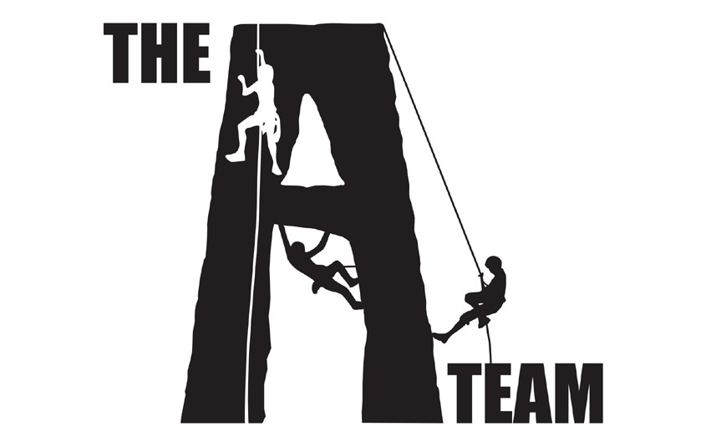

Kia ora,

On behalf of Auckland Sport Climbing Club (ASC), we’d like to invite you to join us for a community forum to discuss the future and direction of the sport in Auckland, priorities and vision for 2023 and beyond, and how ASC can best support the development of rock climbing in the region.

The Auckland Sport Climbing Club is a community club that aims to support the growth of rock climbing as discipline, engage more children and adults into the sport, make it accessible and provide logistical and administrational support for Auckland climbers who want to compete at both a national and international levels.

To succeed, the Club seeks to understand what matters to the community, what areas require extra support and what the shared vision for the future is.

We invite all climbing community members to join us and enjoy some pizza (provided) while meeting new people and having an open discussion that will help us identify the direction for the Club.

**What**: ASC Open Forum

**When**: Sunday 13 November, 11am - 1pm

**Where**: Vincent Street Pop Up (105 Vincent Street, Auckland CBD) **Who**:

* ASC volunteers (hosts)
* Climbers and parents/guardians of young climbers
* Coaches
* Officials
* Gym managers
* Committees
* Volunteers

Please, RSVP via info@@aucklandclimbing.co.nz

We look forward to seeing you,

Auckland Sport Climbing Club